1.Write a C program to merge sort using divide and Conquer

PROGRAM :

#include <stdio.h>

#define max 10

int a[11] = { 10, 14, 19, 26, 27, 31, 33, 35, 42, 44, 0 };

int b[10];

void merging(int low, int mid, int high) {

int l1, l2, i;

for(l1 = low, l2 = mid + 1, i = low; l1 <= mid && l2 <= high; i++) {

if(a[l1] <= a[l2])

b[i] = a[l1++];

else

b[i] = a[l2++];

}

while(l1 <= mid)

b[i++] = a[l1++];

while(l2 <= high)

b[i++] = a[l2++];

for(i = low; i <= high; i++)

a[i] = b[i];

}

void sort(int low, int high) {

int mid;

if(low < high) {

mid = (low + high) / 2;

sort(low, mid);

sort(mid+1, high);

merging(low, mid, high);

} else {

return;

}

}

int main() {

int i;

printf("List before sorting\n");

for(i = 0; i <= max; i++)

printf("%d ", a[i]);

sort(0, max);

printf("\nList after sorting\n");

for(i = 0; i <= max; i++)

printf("%d ", a[i]);

}

OUT PUT :

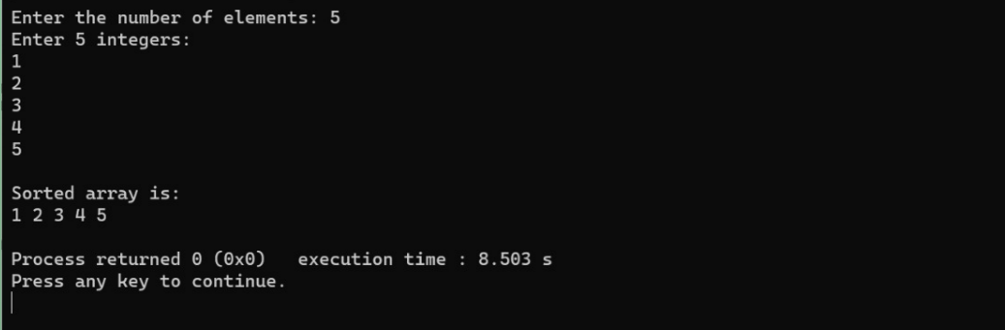

2.Write a C program to find max-min using divide and Conquer

PROGRAM :

#include<stdio.h>

#include<stdio.h>

int max, min;

int a[100];

void maxmin(int i, int j)

{

int max1, min1, mid;

if(i==j)

{

max = min = a[i];

}

else

{

if(i == j-1)

{

if(a[i] <a[j])

{

max = a[j];

min = a[i];

}

else

{

max = a[i];

min = a[j];

}

}

else

{

mid = (i+j)/2;

maxmin(i, mid);

max1 = max; min1 = min;

maxmin(mid+1, j);

if(max <max1)

max = max1;

if(min > min1)

min = min1;

}

}

}

int main ()

{

int i, num;

printf ("\nEnter the total number of numbers : ");

scanf ("%d",&num);

printf ("Enter the numbers : \n");

for (i=1;i<=num;i++)

scanf ("%d",&a[i]);

max = a[0];

min = a[0];

maxmin(1, num);

printf ("Minimum element in an array : %d\n", min);

printf ("Maximum element in an array : %d\n", max);

 return 0;

}

OUT PUT :

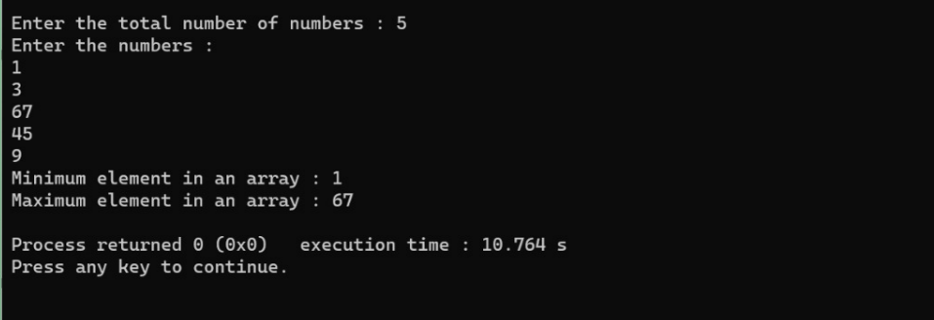

3.Write a program to return all the possible subsets for a given integer array. Return the solution in any order.

Input nums= [1,2,3]

Output : [ [], [1], [2], [3], [1,2], [1,3], [2,3], [1,2,3]]

PROGRAM :

#include <stdio.h>

char string[50], n;

void subset(int, int, int);

int main()

{

int i, len;

printf("Enter the len of main set : ");

scanf("%d", &len);

printf("Enter the elements of main set : ");

scanf("%s", string);

n = len;

printf("The subsets are :\n");

for (i = 1;i <= n;i++)

subset(0, 0, i);

}

void subset(int start, int index, int num_sub)

{

int i, j;

if (index - start + 1 == num_sub)

{

if (num_sub == 1)

{

for (i = 0;i < n;i++)

printf("%c\n", string[i]);

}

else

{

for (j = index;j < n;j++)

{

for (i = start;i < index;i++)

printf("%c", string[i]);

printf("%c\n", string[j]);

}

if (start != n - num_sub)

subset(start + 1, start + 1, num_sub);

}

}

else

{

subset(start, index + 1, num_sub);

    }

}

OUT PUT :

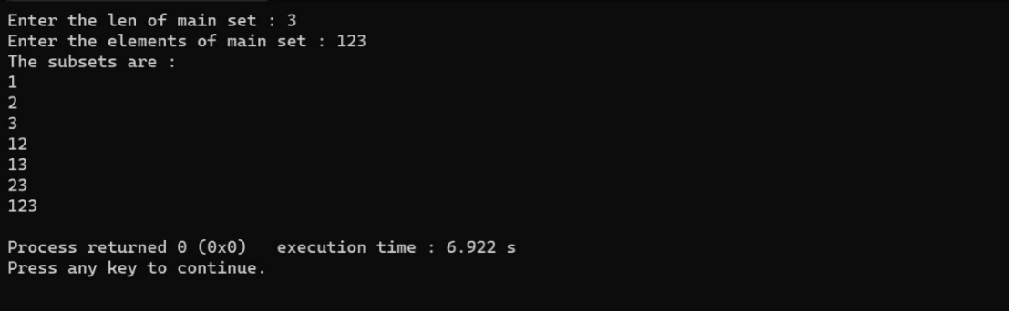

4.Write a program to compute container loader Problem for the given values and estimate time complexity.

N=8 be total no of containers having weights (w1, w2, w3,…w8) = [ 50, 100, 30, 80, 90, 200, 150, 20 ]. Capacity value = 100

PROGRAM :

#include <stdio.h>

#include <stdlib.h>

#define MAX_ITEMS 100

#define MAX_WEIGHT 100

int weight[MAX_ITEMS];

int value[MAX_ITEMS];

int dp[MAX_ITEMS][MAX_WEIGHT];

int max(int a, int b) {

return (a > b) ? a : b;

}

int knapsack(int n, int w) {

int i, j;

for (i = 0; i <= n; i++) {

for (j = 0; j <= w; j++) {

if (i == 0 || j == 0) {

dp[i][j] = 0;

} else if (weight[i-1] <= j) {

dp[i][j] = max(value[i-1] + dp[i-1][j-weight[i-1]], dp[i-1][j]);

} else {

dp[i][j] = dp[i-1][j];

}

}

}

return dp[n][w];

}

int main() {

int n = 4;

int w = 10;

weight[0] = 1;

weight[1] = 2;

weight[2] = 4;

weight[3] = 5;

value[0] = 5;

value[1] = 4;

value[2] = 6;

value[3] = 8;

int result = knapsack(n, w);

printf("Result: %d\n", result);

  return 0;

}

OUT PUT :

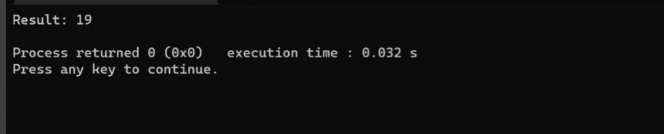

5. Write a program to find a minimum spanning tree using prims technique for the given graph

PROGRAM :

#include <stdio.h>

#include <limits.h>

#define V 5

int minKey(int key[], bool mstSet[]) {

int min = INT_MAX, minIndex;

for (int v = 0; v < V; v++)

if (mstSet[v] == false && key[v] < min)

min = key[v], minIndex = v;

return minIndex;

}

void printMST(int parent[], int graph[V][V]) {

printf("Edge \tWeight\n");

for (int i = 1; i < V; i++)

printf("%d - %d \t%d \n", parent[i], i, graph[i][parent[i]]);

}

void primMST(int graph[V][V]) {

int parent[V];

int key[V];

bool mstSet[V];

for (int i = 0; i < V; i++)

key[i] = INT_MAX, mstSet[i] = false;

key[0] = 0;

parent[0] = -1;

for (int count = 0; count < V - 1; count++) {

int u = minKey(key, mstSet);

mstSet[u] = true;

for (int v = 0; v < V; v++)

if (graph[u][v] && mstSet[v] == false && graph[u][v] < key[v])

parent[v] = u, key[v] = graph[u][v];

}

printMST(parent, graph);

}

int main() {

int graph[V][V] = {{0, 2, 0, 6, 0},

{2, 0, 3, 8, 5},

{0, 3, 0, 0, 7},

{6, 8, 0, 0, 9},

{0, 5, 7, 9, 0}};

primMST(graph);

}

OUT PUT :

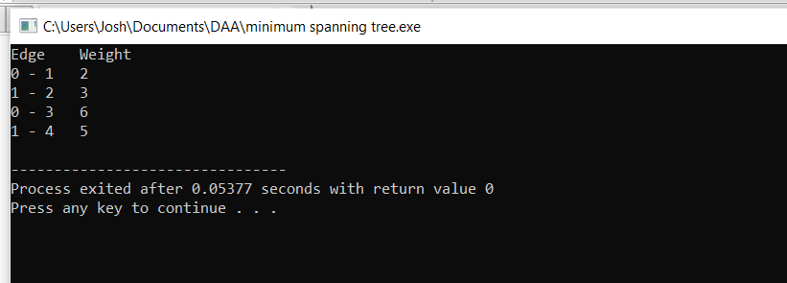

6. Write a program to perform Minimum spanning tree using greedy techniques and estimate time complexity for the given set of values.

PROGRAM :

#include <stdio.h>

#include <limits.h>

#define V 5

int minKey(int key[], int mstSet[]) {

int min = INT_MAX, min_index;

int v;

for (v = 0; v < V; v++)

if (mstSet[v] == 0 && key[v] < min)

min = key[v], min_index = v;

return min_index;

}

int printMST(int parent[], int n, int graph[V][V]) {

int i;

printf("Edge Weight\n");

for (i = 1; i < V; i++)

printf("%d - %d %d \n", parent[i], i, graph[i][parent[i]]);

}

void primMST(int graph[V][V]) {

int parent[V];

int key[V], i, v, count;

int mstSet[V];

for (i = 0; i < V; i++)

key[i] = INT_MAX, mstSet[i] = 0;

key[0] = 0;

parent[0] = -1;

for (count = 0; count < V - 1; count++) {

int u = minKey(key, mstSet);

mstSet[u] = 1;

for (v = 0; v < V; v++)

if (graph[u][v] && mstSet[v] == 0 && graph[u][v] < key[v])

parent[v] = u, key[v] = graph[u][v];

}

printMST(parent, V, graph);

}

int main() {

/* Let us create the following graph

2 3

(0)--(1)--(2)

| / \ |

6| 8/ \5 |7

| / \ |

(3)-------(4)

9 */

int graph[V][V] = { { 0, 2, 0, 6, 0 }, { 2, 0, 3, 8, 5 },

{ 0, 3, 0, 0, 7 }, { 6, 8, 0, 0, 9 }, { 0, 5, 7, 9, 0 }, };

primMST(graph);

    return 0;

}

OUT PUT :

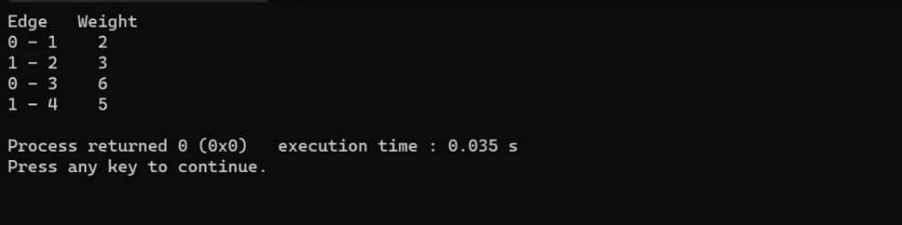

7. Write a program to perform Knapsack problem for the following set of object values., Knapsack weight 100

PROGRAM :

#include <stdio.h>

#include <stdlib.h>

#define MAX(a, b) ((a) > (b) ? (a) : (b))

typedef struct Item {

int weight;

int value;

float ratio;

} Item;

int compare(const void *a, const void *b) {

Item *ia = (Item *)a;

Item *ib = (Item *)b;

return (int)(100.0f * ib->ratio - 100.0f * ia->ratio);

}

void knapsack(Item *items, int n, int weight) {

int i, w;

int value = 0;

qsort(items, n, sizeof(Item), compare);

for (i = 0; i < n; i++) {

if (weight == 0)

break;

w = MIN(weight, items[i].weight);

value += w * items[i].ratio;

weight -= w;

}

printf("Maximum value: %d\n", value);

}

int main() {

Item items[] = {{5, 60, 12.0}, {3, 50, 16.6666667}, {2, 10, 5.0}, {1, 40, 40.0}, {4, 70, 17.5}};

int n = sizeof(items) / sizeof(items[0]);

int weight = 5;

knapsack(items, n, weight);

  return 0;

}

OUT PUT :

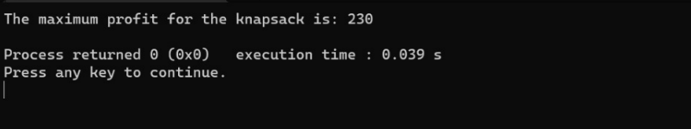

8. The n-queens puzzle is the problem of placing n queens on an n x n chessboard such that no two queens attack each other. Given an integer n, return all distinct solutions to the n-queens puzzle. You may return the answer in any order. Write a program for the same.

PROGRAM :

#include <stdio.h>

#include <stdbool.h>

#define N 8

int col[N];

bool check(int row) {

int i;

for (i = 0; i < row; i++)

if (col[i] == col[row] ||

row - i == col[row] - col[i] ||

row - i == col[i] - col[row])

return false;

return true;

}

void backtrack(int row) {

int i;

if (row == N) {

for (i = 0; i < N; i++) printf("(%d, %d)\n", i, col[i]);

printf("\n");

return;

}

for (i = 0; i < N; i++) {

col[row] = i;

if (check(row)) backtrack(row + 1);

}

}

int main() {

backtrack(0);

  return 0;

}

OUT PUT :

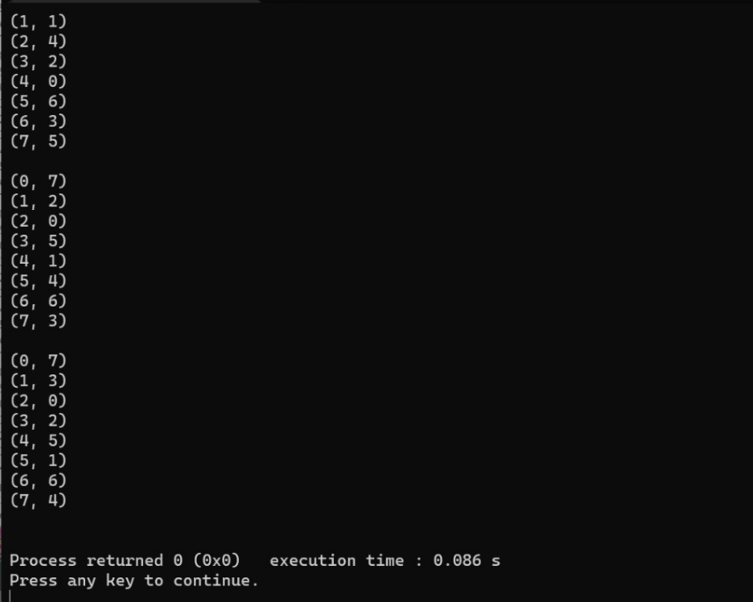

9. Write a program to perform sum of subsets problem using backtracking and estimate time complexity. Identify the test cases.

PROGRAM :

#include <stdio.h>

#include <stdlib.h>

static int total_nodes;

void printValues(int A[], int size){

for (int i = 0; i < size; i++) {

printf("%*d", 5, A[i]);

}

printf("\n");

}

void subset_sum(int s[], int t[], int s_size, int t_size, int sum, int ite, int const target_sum){

total_nodes++;

if (target_sum == sum) {

printValues(t, t_size);

subset_sum(s, t, s_size, t_size - 1, sum - s[ite], ite + 1, target_sum);

return;

}

else {

for (int i = ite; i < s_size; i++) {

t[t_size] = s[i];

subset_sum(s, t, s_size, t_size + 1, sum + s[i], i + 1, target_sum);

}

}

}

void generateSubsets(int s[], int size, int target_sum){

int* tuplet_vector = (int*)malloc(size * sizeof(int));

subset_sum(s, tuplet_vector, size, 0, 0, 0, target_sum);

free(tuplet_vector);

}

int main(){

int set[] = { 5, 6, 12 , 54, 2 , 20 , 15 };

int size = sizeof(set) / sizeof(set[0]);

printf("The set is ");

printValues(set , size);

generateSubsets(set, size, 25);

printf("Total Nodes generated %d\n", total_nodes);

   return 0;

}

OUT PUT :

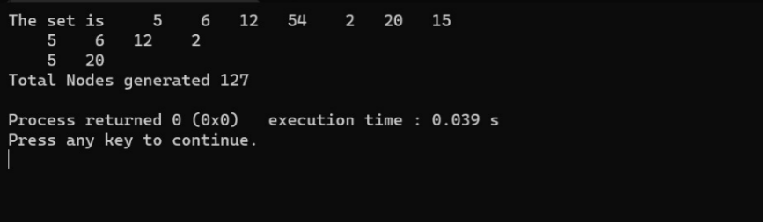

10. Write a C Program for optimum bst

PROGRAM :

#include <stdio.h>

#include <limits.h>

int sum(int freq[], int i, int j);

int optCost(int freq[], int i, int j)

{

if (j < i)

return 0;

if (j == i)

return freq[i];

int fsum = sum(freq, i, j);

int min = INT_MAX;

for (int r = i; r <= j; ++r)

{

int cost = optCost(freq, i, r-1) +

optCost(freq, r+1, j);

if (cost < min)

min = cost;

}

return min + fsum;

}

int optimalSearchTree(int keys[], int freq[], int n)

{

return optCost(freq, 0, n-1);

}

int sum(int freq[], int i, int j)

{

int s = 0;

for (int k = i; k <=j; k++)

s += freq[k];

return s;

}

int main()

{

int keys[] = {10, 12, 20};

int freq[] = {34, 8, 50};

int n = sizeof(keys)/sizeof(keys[0]);

printf("Cost of Optimal BST is %d ",

optimalSearchTree(keys, freq, n));

return 0;

}

OUT PUT :

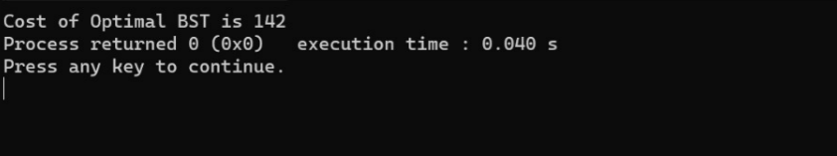

11. travelling salesman problem using dynamic programming for the below given graph.

PROGRAM :

#include <stdio.h>

#include <stdbool.h>

#define MAX 20

#define INF 99999

int n, d[MAX][MAX], x[MAX];

int best_tour_length = INF, tour_length[MAX];

void backtrack(int curr_pos) {

int i;

if (curr_pos == n) {

tour_length[curr_pos] = d[x[n - 1]][x[0]];

int tour = 0;

for (i = 0; i < n; i++) tour += tour_length[i];

if (tour < best_tour_length) best_tour_length = tour;

return;

}

for (i = 0; i < n; i++) {

if (x[i] == -1) {

x[i] = curr_pos;

tour_length[curr_pos] = d[x[curr_pos - 1]][i];

backtrack(curr_pos + 1);

x[i] = -1;

}

}

}

int main() {

int i, j;

printf("Enter the number of cities: ");

scanf("%d", &n);

printf("Enter the distance matrix:\n");

for (i = 0; i < n; i++)

for (j = 0; j < n; j++) {

scanf("%d", &d[i][j]);

x[i] = -1;

}

x[0] = 0;

backtrack(1);

printf("The minimum tour length is: %d\n", best_tour_length);

  return 0;

}

OUT PUT :

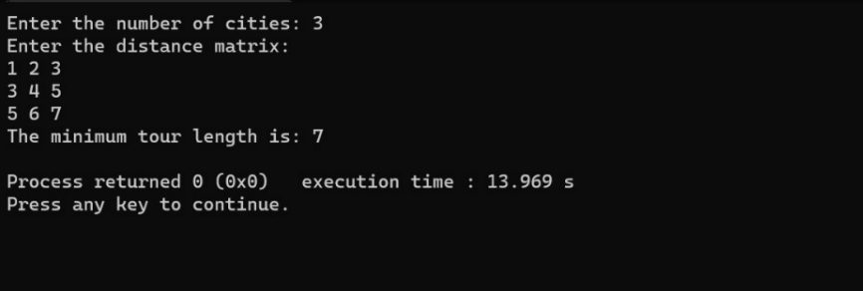

12. Identify the M-th maximum number and Nth minimum number in an array and then find the sum of it and difference of it.

PROGRAM :

#include <stdio.h>

int main ()

{

int number[30],rev[30];

int i, j, a, n,m,nt;

printf("Enter the value of N\n");

scanf("%d", &n);

printf("Enter the numbers \n");

for (i = 0; i < n; ++i)

scanf("%d", &number[i]);

for (i = 0; i < n; ++i)

{

for (j = i + 1; j < n; ++j)

{

if (number[i] < number[j])

{

a = number[i];

number[i] = number[j];

number[j] = a;

}

}

}

for(i=(n-1),j=0; i>=0; i--,j++)

{

rev[j]=number[i];

}

printf("\nEnter the Mth maximum =");

scanf("%d",&m);

printf("\n%d th maximum number is %d",m,number[m-1]);

printf("\nEnter the Nth minimum =");

scanf("%d",&nt);

printf("\n%d th minimum number is %d",nt,rev[nt-1]);

return 0;

 }

OUT PUT :

